IMPORT DATA USING TRANSFORM MAPS
(SPREADSHEET)

A project submitted by

Government arts and science college for women

A. Manjula : 24081371802112127
M. Joice Deniba : 24081371802112117
I. Helshiya Mary : 24081371802112113
S. Rubika : 24081371802112140
G. Abisha 24081371802112101

TABLE OF CONTENTS
- Introduction
- Project Objectives
- Scope of the Project
- Technologies and Tools Used
- Project Methodology
- Phase 1 – Prepare the Spreadsheet
- Phase 2 – Create Employee Test Table
- Phase 3 – Create Import Set Table
- Phase 4 – Create Transform Map
- Phase 5 – Transform and Validate Data
- Phase 6 – Enable Coalesce
- Phase 7 – Insert New Excel Data and Testing
- Phase 8 – Create Reports
- Phase 9 – Create Dashboard
- System Testing and Results
- Advantages

- Limitations
- Future Enhancement
- Conclusion
- Screenshot Evidence Section

ABSTRACT
The project “Import Data using Transform Maps (Spreadsheet)” demonstrates how structured employee data from an external spreadsheet can be imported into ServiceNow in an organized and controlled manner. The project uses ServiceNow Import Sets and Transform Maps to move employee information from a spreadsheet into a custom Employee Test table.
The process begins by preparing sample employee data in a spreadsheet and downloading it in Excel format. A custom Employee Test table is created with fields such as Employee ID, Employee Name, Email, Department and Location. An Employee Import table is then used as the staging area for the spreadsheet data. A Transform Map named Sample Spreadsheet Import connects the source fields with the corresponding target fields.
After the transformation is executed, the imported records are validated in the Employee Test table. Coalesce is enabled to identify existing employee records during repeated imports. The documented test demonstrates that new employee IDs can be inserted, existing employee IDs can be updated, and repeated identical data can be ignored instead of creating unnecessary duplicates.
The project is further extended with reporting and dashboard features. Three reports are created: Employees by Department, Employees by Location, and Employee List Report. These reports are added to the Employee Analytics Dashboards dashboard to provide a centralized view of employee information.
Overall, the project provides practical understanding of spreadsheet data import, staging, field mapping, transformation, validation, duplicate prevention, reporting and dashboard creation in ServiceNow.

INTRODUCTION
In many organizations, employee information is maintained in spreadsheets and must be transferred into an enterprise platform. Manual entry of large amounts of employee information can be time-consuming and may result in inconsistent or duplicate records. ServiceNow provides Import Sets and Transform Maps to support structured data loading and transformation.
This project focuses on importing employee information from a spreadsheet into a custom ServiceNow table. The imported data passes through an Import Set table before being transformed into the target Employee Test table. The project also demonstrates Coalesce for duplicate prevention and the creation of reports and a dashboard for viewing employee information.

PROJECT OBJECTIVES
- To prepare structured employee data in spreadsheet format.
- To create a custom Employee Test table in ServiceNow.
- To create an Import Set table for staging spreadsheet data.
- To create and configure a Transform Map.
- To map source spreadsheet fields to target ServiceNow fields.
- To transform and validate imported employee records.
- To configure Coalesce to avoid unnecessary duplicate records.
- To test insertion of new employee records and updating of existing records.
- To create department-wise, location-wise and list-based employee reports.
- To create the Employee Analytics Dashboards dashboard and add the reports to it.

SCOPE OF THE PROJECT
The project scope covers the complete workflow described in the supplied project material: spreadsheet preparation, custom table creation, Import Set creation, Transform Map configuration, data transformation, validation, Coalesce testing, report creation and dashboard configuration. The project is focused on employee data and does not extend to other business processes outside the documented workflow.

TECHNOLOGIES AND TOOLS USED
Technology / Tool | Purpose
ServiceNow | Platform used to implement the complete project
Google Spreadsheet | Preparation of sample employee data
Excel (.xlsx) | Source format used for data import
Import Sets | Staging imported spreadsheet data
Transform Maps | Mapping source data to target fields
Employee Test Table | Target storage for employee records
Reports | Analysis and presentation of employee data
Dashboards | Centralized presentation of reports

PROJECT METHODOLOGY
The project follows a sequential data-import methodology. First, sample employee information is prepared. Next, the target and staging tables are created. A Transform Map is configured to connect source and target fields. The data is then transformed and validated. Coalesce is configured and tested to control repeated imports. Finally, reports and a dashboard are created.

Project workflow:
Prepare Spreadsheet → Create Employee Test → Create Import Set → Create Transform Map → Transform & Validate → Enable Coalesce → Test New/Existing Data → Create Reports → Create Dashboard

PHASE 1 – PREPARE THE SPREADSHEET
The first phase prepares the source data. A new Google Spreadsheet is created with sample employee data and then downloaded as Sample Spreadsheet.xlsx. This Excel file is used during the ServiceNow import process.

Procedure
- Open Google Spreadsheet.
- Create a new spreadsheet.
- Enter the sample employee information.
- Verify the spreadsheet data.
- Download the spreadsheet in .xlsx format.
- Save the file as Sample Spreadsheet.xlsx.

SCREENSHOT 1
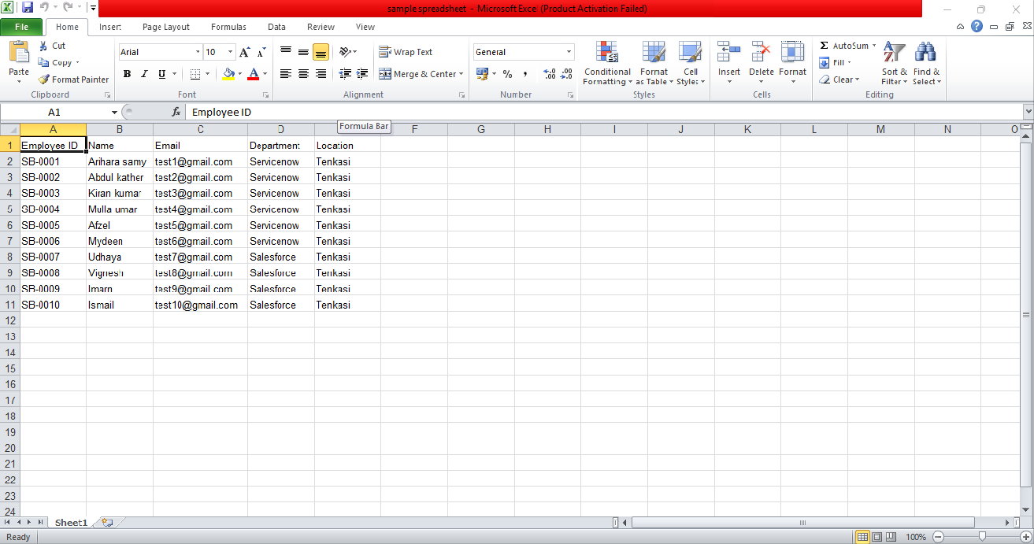
Prepared Employee Spreadsheet

PHASE 2 – CREATE EMPLOYEE TEST TABLE
A custom table named Employee Test is created to store the transformed employee information.

Property | Value
Label | Employee Test
Name | u_employee_test

Fields Created
Field | Type
Employee ID | String
Employee Name | String
Email | String
Department | String
Location | String

The required fields are added through the table form layout and verified on the Employee Test form.

SCREENSHOT 2

Employee Test Table
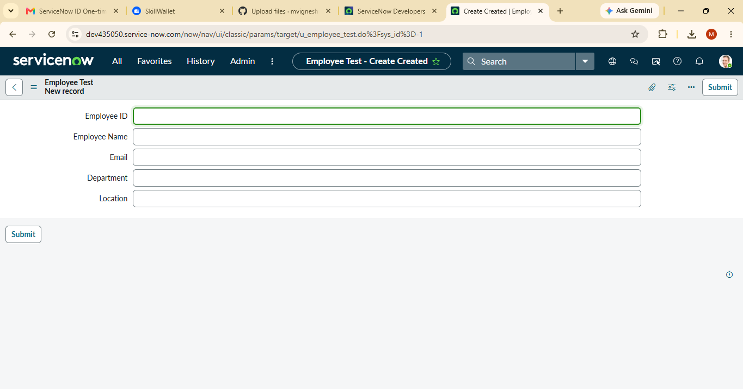

PHASE 3 – CREATE IMPORT SET TABLE
The Import Set table acts as a staging area for spreadsheet data before the data is transformed into the Employee Test target table.

Property | Value
Label | Employee Import
Name | u_employee_import

Procedure
- Open All menus.
- Search for Load Data.
- Open Load Data.
- Create an Import Set table.
- Enter Employee Import as the label.
- Submit the form.
- Proceed to create the Transform Map.

SCREENSHOT 3

Employee Import / Load Data

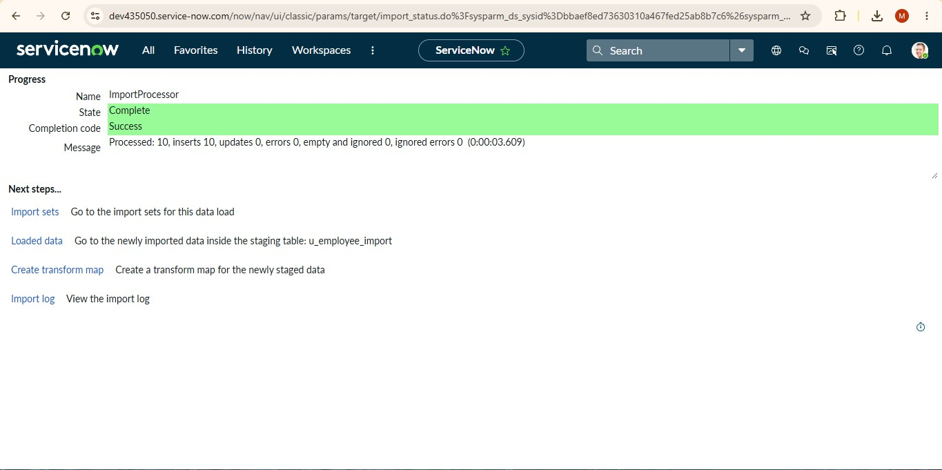

PHASE 4 – CREATE TRANSFORM MAP
The Transform Map defines how the source Employee Import fields are transferred to the target Employee Test fields.

Property | Value
Transform Map Name | Sample Spreadsheet Import
Source Table | Employee Import
Target Table | Employee Test

Field Mapping
Source Field | Target Field
Employee ID | Employee ID
Employee Name | Employee Name
Email | Email
Department | Department
Location | Location

Auto Map Matching Fields can be used, followed by Mapping Assist to verify the source and target field connections.

SCREENSHOT 4

Transform Map Configuration
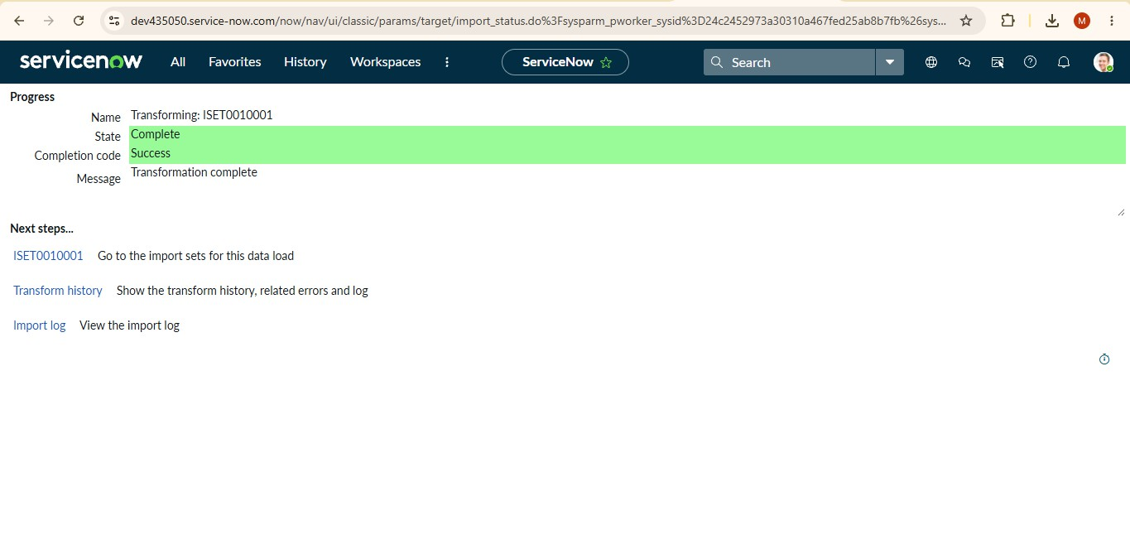

PHASE 5 – TRANSFORM AND VALIDATE DATA
After the Transform Map is configured, the transformation is executed. The resulting records are checked in the Employee Test table to verify that the imported information has been created correctly.

Validation Points
- Transform execution completes successfully.
- Employee records appear in Employee Test.
- Employee ID values are present.
- Employee names and email addresses are present.
- Department and Location values are displayed.
- The fields can be arranged using Personalized List Columns when required.

SCREENSHOT 5

Successful Transform Result
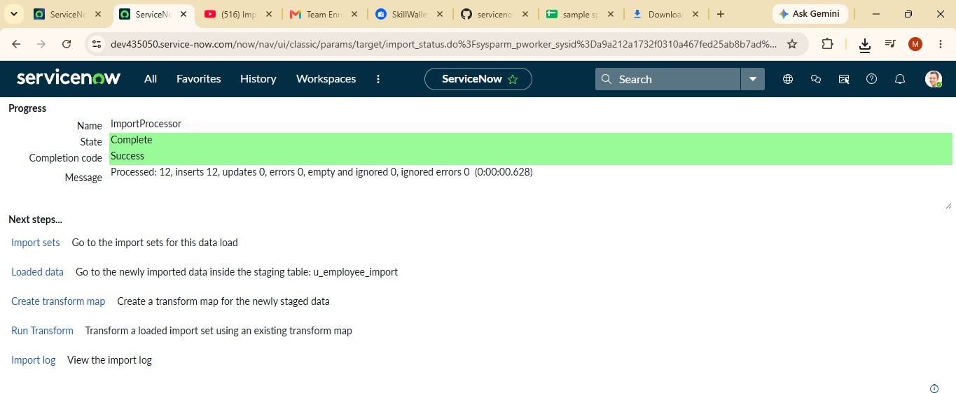

SCREENSHOT 6

Employee Test Records

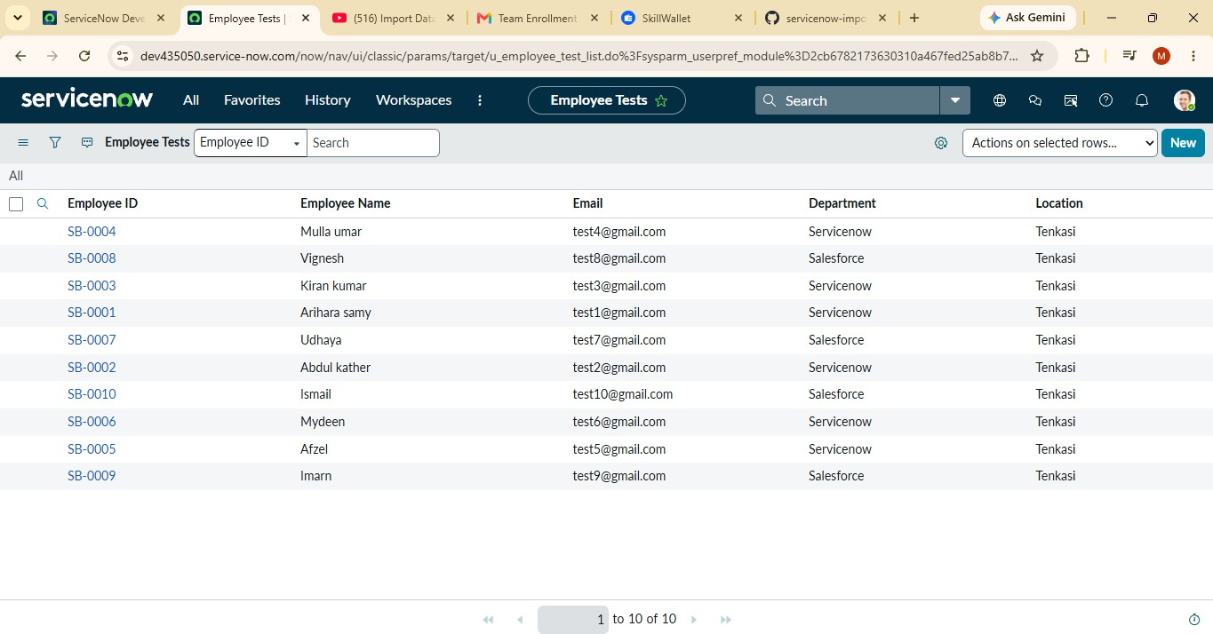

PHASE 6 – ENABLE COALESCE
Coalesce is used to identify existing records during repeated imports. A field in the Transform Map is configured as a Coalesce field. The documented project uses Employee ID for identifying existing employee records.

Purpose
- Identify existing employee records during import.
- Update matching records rather than creating unnecessary duplicate records.
- Keep employee information consistent during repeated spreadsheet imports.

SCREENSHOT 7

Coalesce Configuration
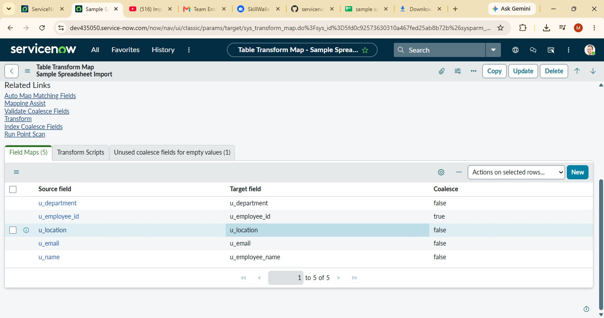

PHASE 7 – INSERT NEW EXCEL DATA AND TESTING
A new Excel file is imported using the existing Employee Import table and Transform Map. The documented test contains four rows: two new employee IDs and two existing employee IDs with changed values.

Documented Test Result
Test | Inserted | Updated | Ignored
First changed spreadsheet  import | 2 | 2 | 0
Same spreadsheet imported  again | 0 | 0 | 4

The result demonstrates the intended behavior of Coalesce: new IDs are inserted, matching IDs are updated when their data changes, and an identical repeated import does not create additional records.

SCREENSHOT 8

Load Data Configuration

SCREENSHOT 9

Transform History / Test Result

PHASE 8 – CREATE REPORTS
Three reports are created from the Employee Test table to provide different views of the imported employee data.

Employees by Department
Setting | Value
Report Name | Employees by Department
Source Type | Table
Table | Employee Test
Type | Pie Chart
Group By | Department
Aggregation | Count

SCREENSHOT 10

Employees by Department Report

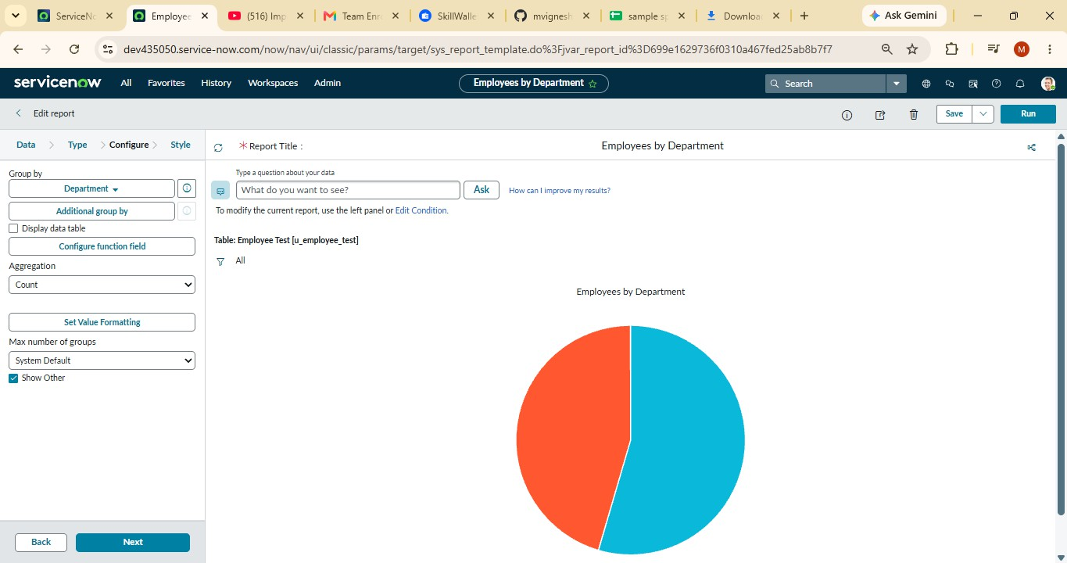

Employees by Location
Setting | Value
Report Name | Employees by Location
Table | Employee Test
Type | Bar Chart
Group By | Location
Aggregation | Count

SCREENSHOT 11

Employees by Location Report
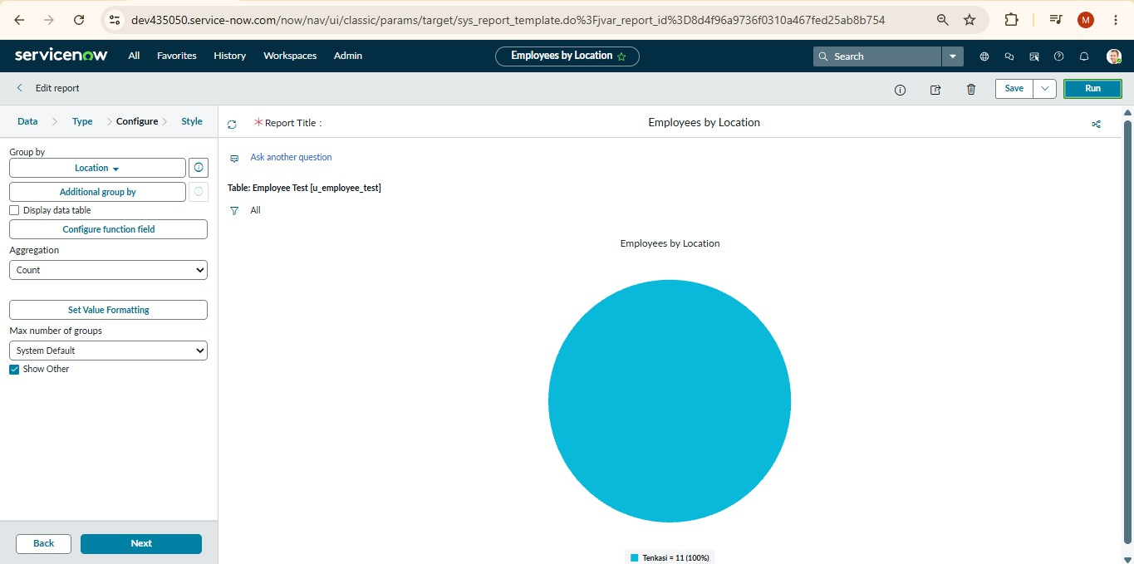

Employee List Report
Setting | Value
Report Name | Employee List Report
Table | Employee Test
Type | List
Columns | Employee ID; Employee Name; Email; Department; Location

SCREENSHOT 12

Employee List Report
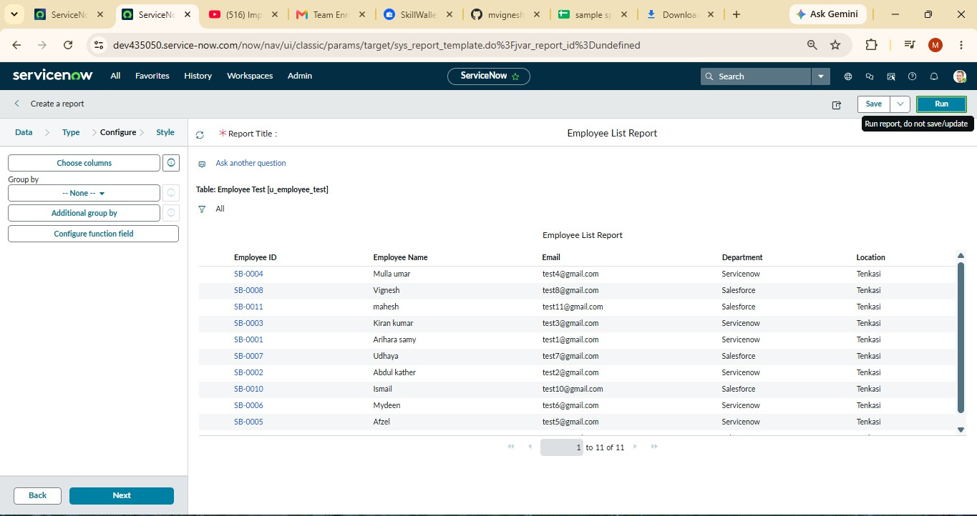

PHASE 9 – CREATE DASHBOARD
The three reports are consolidated into a dashboard named Employee Analytics Dashboards. The dashboard provides a centralized view of the employee information.

Dashboard Property | Value
Dashboard Name | Employee Analytics Dashboards

Reports Added
- Employees by Department
- Employees by Location
- Employee List Report

Adding Reports
- Open the previously created report.
- Open the Share option.
- Select Add to Dashboards.
- Choose Employee Analytics Dashboards.
- Click Add.
- Repeat the process for the remaining two reports.

SCREENSHOT 13

Add Report to Dashboard
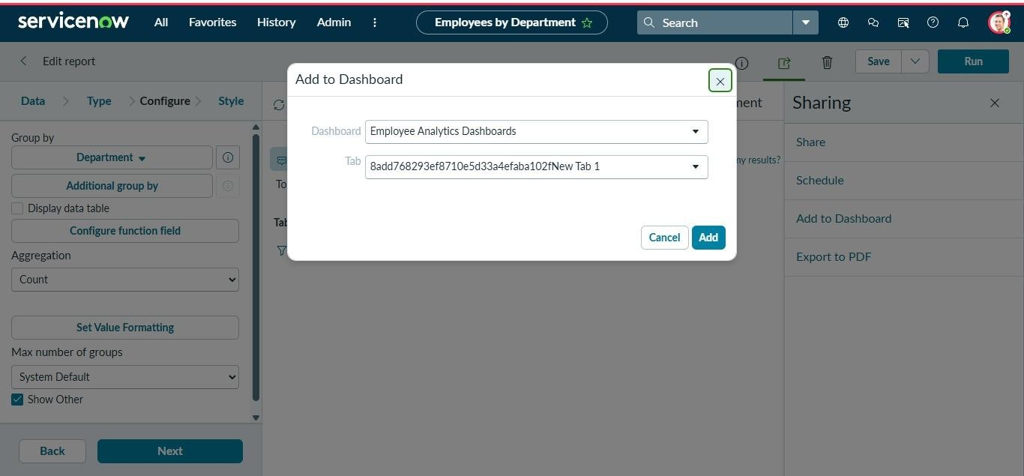

SCREENSHOT 14

Completed Employee Analytics Dashboards
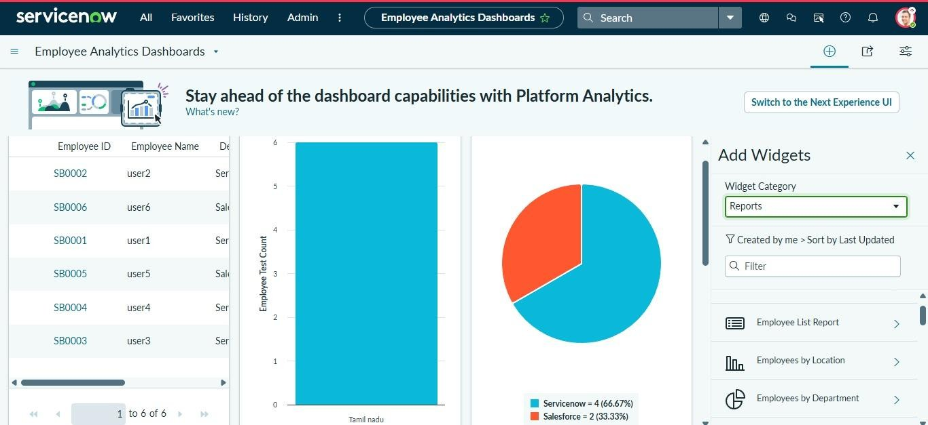

SYSTEM TESTING AND RESULTS
Testing is performed at different stages of the project to verify the import, transformation, duplicate prevention and reporting workflow.

Test Case | Expected Result | Result
Spreadsheet import | Data loaded into Import Set | Successful
Transform Map execution | Source data mapped to target | Successful
Employee Test validation | Imported records displayed | Successful
New Employee IDs | New records inserted | 2 inserted in documented test
Existing Employee IDs | Existing records updated | 2 updated in documented test
Repeated identical sheet | No duplicate records created | 4 ignored in documented test
Department report | Employee count grouped by department | Created
Location report | Employee count grouped by location | Created
List report | Employee details displayed | Created
Dashboard | All three reports displayed together | Configured

ADVANTAGES
- Supports bulk employee data import from spreadsheets.
- Reduces the need for manual record creation.
- Provides structured source-to-target field mapping.
- Allows validation after transformation.
- Coalesce helps avoid unnecessary duplicate records.
- Existing employee information can be updated during import.
- Reports provide department-wise and location-wise views.
- Dashboard provides a centralized view of the reports.

LIMITATIONS
- The project is based on the employee data structure defined for this micro project.
- The source spreadsheet must contain data in the expected format and fields.
- The report and dashboard configurations depend on ServiceNow access and permissions.
- The project does not document business processes outside the spreadsheet import and reporting workflow.

FUTURE ENHANCEMENT
- Additional employee fields can be introduced when required by the organization.
- More report types can be created for additional analysis.
- Additional dashboard widgets can be added for broader monitoring.
- Import validation rules can be expanded for larger real-world datasets.
- Additional automation can be introduced around recurring imports.

CONCLUSION
The Import Data using Transform Maps (Spreadsheet) project successfully demonstrates an end-to-end employee data import workflow in ServiceNow. The project begins with spreadsheet preparation and continues through Import Set creation, Transform Map configuration, data transformation and validation.
The use of Coalesce provides a mechanism for identifying existing employee records during repeated imports. The documented testing demonstrates insertion of new employee IDs, updating of existing records and ignoring identical repeated data.
The project is completed with three reports and the Employee Analytics Dashboards dashboard. The reports provide department-wise, location-wise and detailed list views of employee data, while the dashboard brings the reports together in a centralized view.

SCREENSHOT EVIDENCE SECTION
Use this section to paste the actual screenshots captured during the project implementation. Each placeholder is labeled so that the evidence can be matched with the corresponding project phase.

SCREENSHOT 1

Spreadsheet preparation
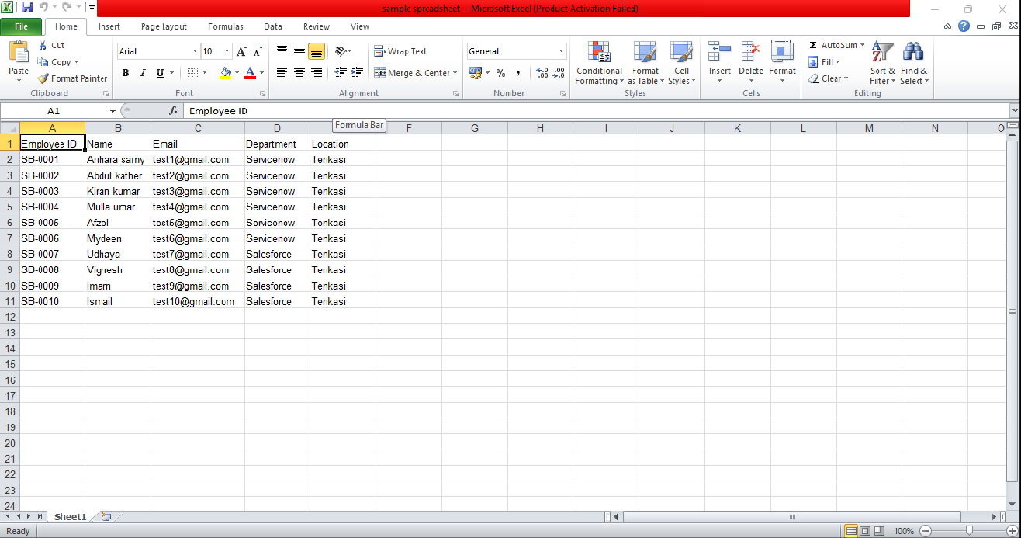

SCREENSHOT 2

Employee Test table

SCREENSHOT 3

Employee Import / Load Data

SCREENSHOT 4

Transform Map and field mapping
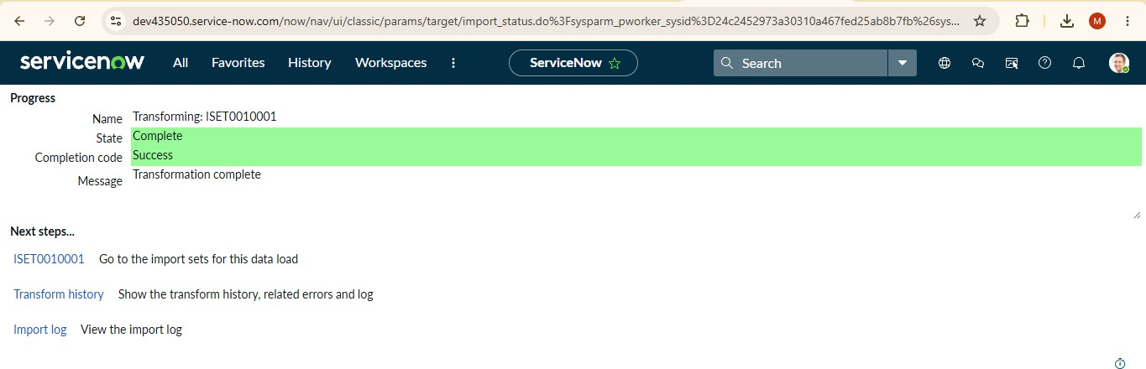

SCREENSHOT 5

Successful transformation

SCREENSHOT 6

Employee Test imported records

SCREENSHOT 7

Coalesce enabled

SCREENSHOT 8

New Excel data import

SCREENSHOT 9

Transform history result

SCREENSHOT 10

Employees by Department report

SCREENSHOT 11

Employees by Location report

SCREENSHOT 12

Employee List Report

SCREENSHOT 13

Add Report to Dashboard

SCREENSHOT 14

Final dashboard with all reports

